Blue2

Jon Flores, Aaron Gavin, Bowen Mei

**Functional System Requirements**

Functional System Requirements

for

Blue2

Prepared by:

_____________________________

Author Date

Approved by:

_____________________________

Project Leader Date

_____________________________

John Lusher, P.E. Date

_____________________________

T/A Date

**Change Record**

| **Rev.** | **Date** | **Originator** | **Approvals** | **Description** |
| --- | --- | --- | --- | --- |
| **1** | 9/19/2021 | Team 13 |  | Draft Release |
| **2** | 11/28/2021 | Team 13 |  | 1st Revision |
| **3** | 4/28/2022 | Team 13 |  | Final Revision |

**Table of Contents**

**Table of Contents 3**

**List of Figures 4**

**1.** **Introduction 5**

1.1. Purpose and Scope 5

1.2. Responsibility and Change Authority 6

**2.** **Applicable and Reference Documents 7**

2.1. Applicable Documents 7

2.2. Reference Documents 7

2.3. Order of Precedence 8

**3.** **Requirements 9**

3.1. System Definition 9

3.2. Characteristics 10

3.2.1 Functional / Performance Requirements 10-11

3.2.2 Physical Characteristics 11-12

3.2.3 Electrical Characteristics 13-14

3.2.4 Environmental Requirements 14

**4.** **Support Requirements 14**

Appendix A: Acronyms and Abbreviations 15

**List of Figures**

**Figure 1. Microcontroller Connection with Phone Application 5**

**Figure 2. Block Diagram Overview of System** **9**

**Figure 3. Block Diagram of the Data Path of the System 10**

# 

# Introduction

## Purpose and Scope

This specification defines the technical requirements for the development items and support subsystems delivered to the client for the project. Figure 1 shows a representative integration of the project in the proposed CONOPS. The verification requirements for the project are contained in a separate Verification and Validation Plan.

The Blue2 device is a portable system that provides the necessary functions to perform ECEN 215 labs like the user would in a lab setting. This device will be useful for students performing these labs in a distance learning format. It is designed to be downloaded and controlled as a phone application by the non-electrical engineering student who is taking the ECEN 215 course. In the phone application, the user will be able to read continuous data for each analysis device separately. These analysis devices are an ammeter, an oscilloscope, an ohmmeter, a variable amplitude and frequency wave generator, DC power supplies, and a voltmeter. These will take place of the required measurement equipment inside the labs.



**Figure 1. Microcontroller Connection with Phone Application**

## Responsibility and Change Authority

The team leader, Jon Flores, will be responsible for verifying that all requirements of the project are met. These requirements can only be changed with the approval of the team leader and Professor John Lusher II.

| **Subsystem** | **Responsibility** |
| --- | --- |
| Hardware/Firmware (Oscilloscope, Ohmmeter, Voltmeter, and Microcontroller) | Jon Flores |
| Hardware/Firmware (Ammeter, DC Power Supplies, Wavegenerator, and Microcontroller) | Aaron Gavin |
| Software (Microcontroller and Phone Application) | Bowen Mei |

# Applicable and Reference Documents

## Applicable Documents

The following documents, of the exact issue and revision shown, form a part of this specification to the extent specified herein:

| **Document Number** | **Revision/Release Date** | **Document Title** |
| --- | --- | --- |
| IEEE P1573 | 3/31/2011 | IEEE Draft Recommended Practice for Electronic Power Subsystems: Parameters, Interfaces, Elements, and Performance |
| SBAS890C | September 2008 | 2.7V 4-Channel/8-Channel 12-Bit A/D Converters with SPI Serial Interface |
| DS22244B | April 2010 | 8/10/12-Bit Voltage Output Digital-to-Analog Converter with Internal VREF and SPI Interface |
| ESP32-WROOM-32E | 2/22/2022 | ESP-32-WROVER Datasheet v1.4 |
| DS60001402G | 2019 | PIC32MK GENERAL PURPOSE AND  MOTOR CONTROL (GP/MC) FAMILY |

## Reference Documents

The following documents are reference documents utilized in the development of this specification. These documents do not form a part of this specification and are not controlled by their reference herein.

| **Title** | **URL** |
| --- | --- |
| Bluetooth Core Specification | <https://vtsociety.org/wp-content/uploads/2019/07/Core_v5.1.pdf> |
| Documentation for app developers | <https://developer.android.com/docs> |
| C Reference | <https://devdocs.io/c/> |
| What is ESP32 and Why Is It Best for IoT Projects? | <https://www.iottechtrends.com/what-is-esp32/#:~:text=ESP32%20is%20a%20low-powered%2C%20low-cost%20microcontroller%20%28MCU%29%20board%2C,and%20is%20based%20on%20a%20dual-core%20processor%20mechanism>. |
| ESP-IDF Programming Guide | <https://docs.espressif.com/projects/esp-idf/en/latest/esp32/> |
| Espressif Github | <https://github.com/espressif> |
| AD2 - Digilent Reference | [Starting with the Analog Discovery 2 - Digilent Reference](https://digilent.com/reference/waveforms3/analogdiscovery2) |

## Order of Precedence

In the event of a conflict between the text of this specification and an applicable document cited herein, the text of this specification takes precedence without any exceptions.

All specifications, standards, exhibits, drawings or other documents that are invoked as “applicable” in this specification are incorporated as cited. All documents that are referred to within an applicable report are considered to be for guidance and information only, except ICDs that have their relevant documents considered to be incorporated as cited.

# Requirements

## System Definition

The Blue2 device is intended to be used by ECEN 215 students, and it will house all of the required functionality for the students to complete their labs. The Blue2 device will take input parameters from the phone app and output desired measured values onto the phone screen. Both inputs from the user and outputs from the device will be transmitted over a Bluetooth connection.

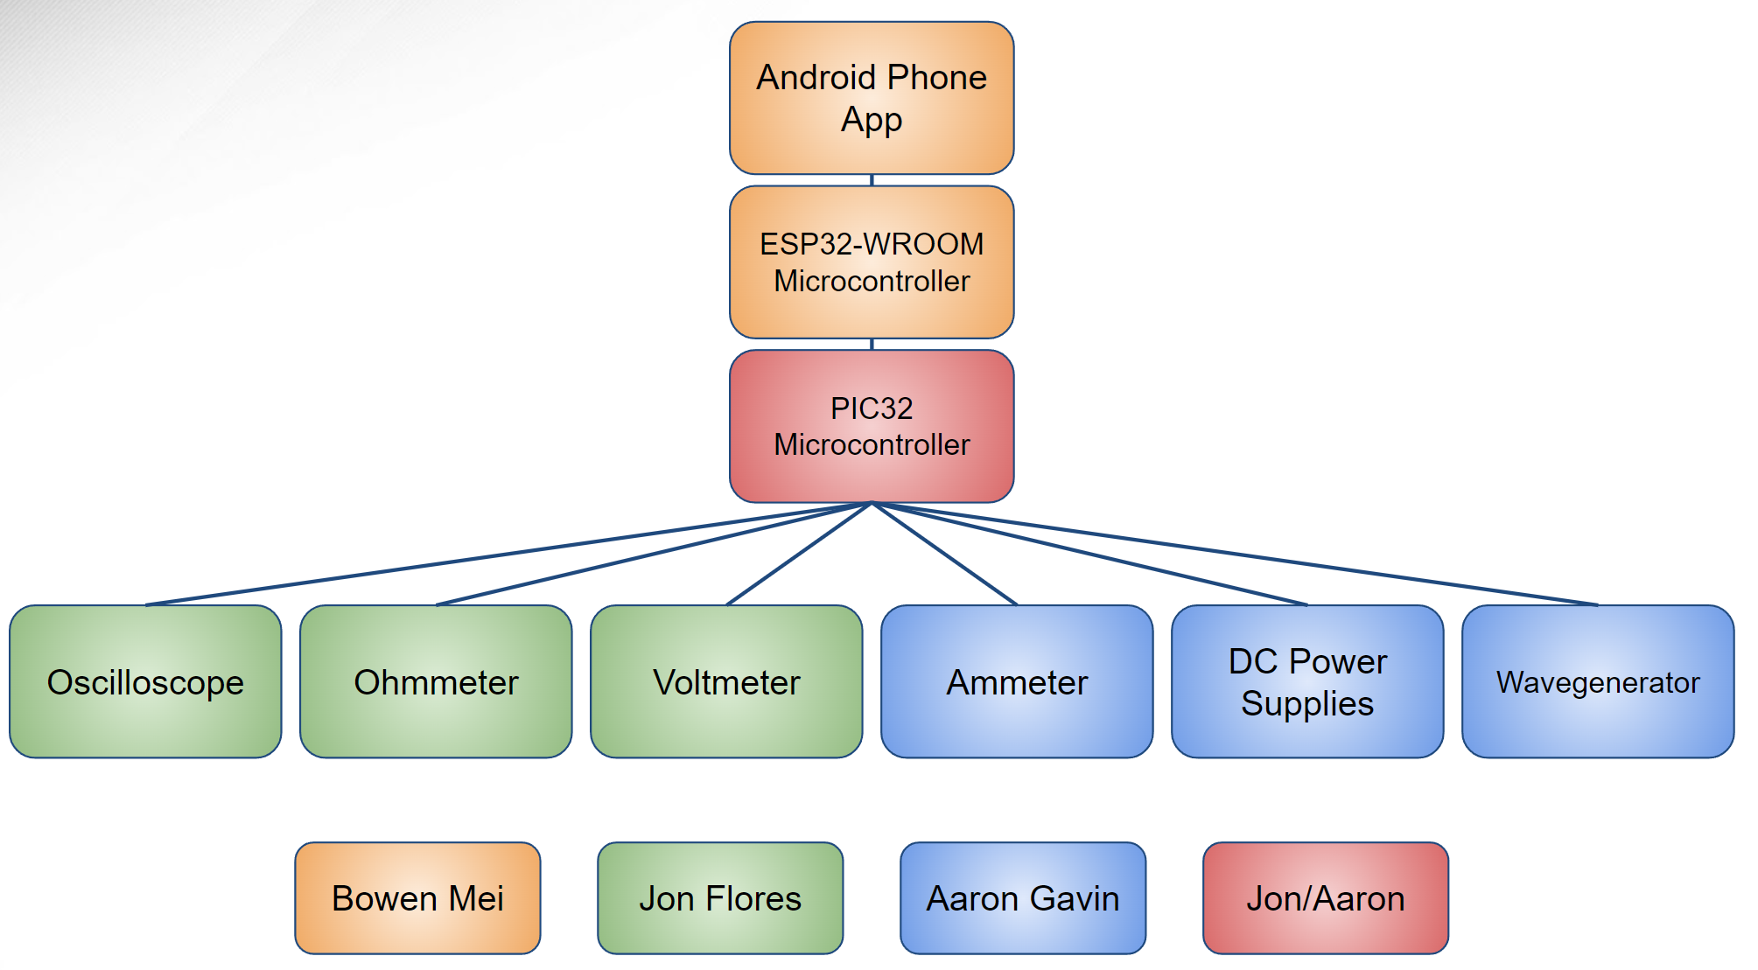

**Figure 2. Block Diagram Overview of System**

All of the data-gathering instruments will funnel through the microcontroller and Bluetooth chip. The Bluetooth chip will send the data via Bluetooth to a phone where it can be viewed using an app. Input parameters from the user will be entered into the phone app and passed on to the instruments.

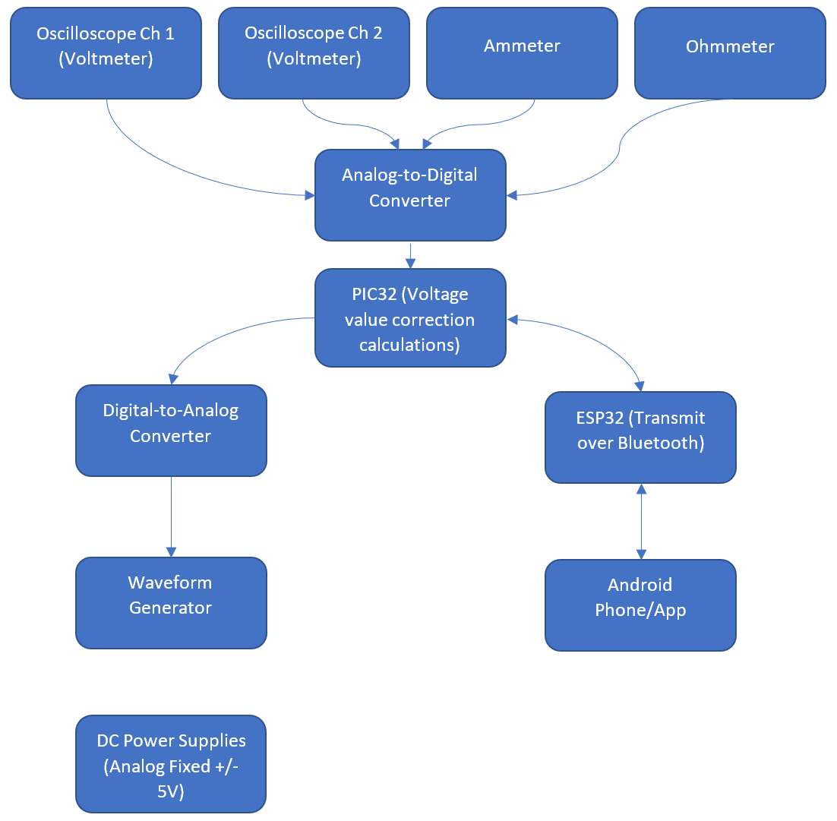

**Figure 3. Block Diagram of the Data Path of the System**

## Characteristics

### Functional / Performance Requirements

### Bluetooth Capability

The Blue2 device will have a Bluetooth connection with speeds of up to 12 Mb/s between the ESP32 hardware and Andriod phone app software.

*Rationale: This specification is required by our sponsor and grants more flexibility with a wireless connection versus a traditional wired connection.*

#### Instruments

The Blue2 device will house all of the required measurement instruments for completing all of the ECEN 215 labs. This includes an oscilloscope, an ohmmeter, an ammeter, a variable amplitude and frequency wave generator, DC power supplies, and a voltmeter.

*Rationale: This is the core system performance requirement. The instrumentation device will need to perform these functions to be useful for ECEN 215 students.*

* + - * 1. **Oscilloscope**

The oscilloscope on the Blue2 device will need to be able to analyze the waves generated by the wavegenerator. In the lab it is required to output 15 different waveforms. It needs to have two channels. Each channel includes a positive and negative lead for the user to apply to their circuit. The voltage input for this function will be in range of -5 to +5 V, the sampling rate is 1440 Hz, the resolution will be a 12-bit ADC, and the maximum error will be ±0.2%.

*Rationale: The ECEN 215 lab manual and sponsor require this functionality.*

* + - * 1. **Voltmeter**

The voltmeter on the Blue2 device will measure DC and AC voltages of a circuit up to 5V using the two oscilloscope channels. The voltmeter reading will be the difference between the two measured channels. This will have a maximum error of ±0.2%. For example, when measuring for 5V, the resolution is 10mV.

*Rationale: This requirement is based off of the maximum voltage the DC power supplies will be able to input.*

* + - * 1. **Ohmmeter**

The ohmmeter on the Blue device will measure resistance values of a circuit between 47 Ω to 10 kΩ. This will have a maximum error of ±0.2%.

*Rationale: Most commercially available digital multimeters are able to measure resistances between a few hundred ohms and one million ohms. The ECEN 215 lab manual requires resistance measurements of 47* Ω and 10 kΩ.

* + - * 1. **Ammeter**

The ammeter on the Blue2 device will measure the current of a circuit up to 120 mA. This will have a maximum error of ±0.2%.

*Rationale: The ECEN 215 lab manual requires measuring current up to 120 mA.*

* + - * 1. **DC Power Supplies**

The Blue2 device will have DC power supplies that will provide -5 V and +5 V via probe wires.

*Rationale: The ECEN 215 lab manual and sponsor require these values.*

* + - * 1. **Wavegenerator**

The wavegenerator on the Blue2 device will require a set frequency based on the lab requirements. This function will need to produce Sine waves with frequencies up to 1200 Hz and amplitudes of up to 5 V. The wavegenerator will need to produce Square waves with frequencies up to 30 Hz and amplitudes of up to 1 V. The wavegenerator will need to produce Triangle waves with frequencies up to 30 Hz and amplitudes of up to 0.5 V.

*Rationale: The ECEN 215 lab manual and sponsor require these values.*

* + - 1. **Software**

The software placed on the Blue2 device’s supplementary android device, usually the user’s android phone, is able to display the data that Blue2 collects from the measurement instruments in an easy to read format. It also will have a way to take input and send that data to the Blue2 to create a signal from the input.

*Rationale: This is the main display for the Blue2’s output as well as its input for the waveform generator. It allows the user to easily show and take screenshots of their outputs for lab reports.*

* + - 1. **Power Distribution**

The power distribution subsystem will input a nominal 20 V and output stable 5 V, -5 V, and 3.3 V power lines for use in subsystem functions, PCB power, and IC chip power.

*Rationale: 5 V, -5 V, and 3.3 V are used as voltage supplies for the PIC32, ESP32, various opamps and various subsystems.*

### Physical Characteristics

#### Mass

The mass of the Blue2 device will be less than or equal to 2.25 kg.

*Rationale: The Blue2 device seeks to replace the already existing AD2 which weighs about 0.25 kg. However, the 2.25 kg weight target is far less than the heavy bench equipment which the Blue2 will replace.*

#### Volume

The dimensions of the Blue2 device will be less than or equal to 24 cm x 24 cm x 8 cm. The volume of the Blue2 device will be less than or equal to 4608 cm³.

*Rationale: The Blue2 should be small enough to fit in a student’s backpack. The Blue2 device should also be smaller than the large bench equipment that the Blue2 is replacing.*

* + 1. **Electrical Characteristics**

#### Inputs

The software will limit the inputs from the user to keep the system within a safe operating range.

*Rationale: This is so that the user is not able to break the device unintentionally.*

##### Power Consumption

The maximum peak power of the system shall not exceed 20 W.

*Rationale: This is a requirement due to the limitations of the system in which the Blue2 device is operating one or multiple instruments.*

##### Input Voltage Level

The input voltage level for the Blue2 device shall be be 20 V coming from the wall wart power supply. The user will utilize +/- 5 V DC power supplies from the DC Power Supplies subsystem. The voltage inputs to the Power Distribution subsystem is 20 V. The voltage outputs from the Power Distribution subsystem will be 5 V, -5 V, and 3.3 V. These voltages will be used by the user and/or for the supplies to other subsystems.

*Rationale: The combined voltage requirements for the measurement devices is at least 5V.*

#### Outputs

##### Data Output

The Blue2 device shall output collected data through analog-to-digital converters to the display of an android phone via an android app. The Blue2 will also output generated waveforms at the user’s request through a digital-to-analog converter.

*Rationale: The Blue2 device output passes directly to the user’s phone*

**Single Value Outputs**

The Blue2’s output device will allow the user to find instantaneous single values for voltage, current, and resistance.

*Rationale: The ECEN 215 lab manual has procedures where the student must take single values outputs such as resistance, which don’t change over time*

**Waveform**

The Blue2’s output device will allow the user to view the waveform for voltage via oscilloscope measurements.

*Rationale: The ECEN 215 lab manual has procedures that require the student to be able to view the waveform of the voltage*

##### Diagnostic Output

The Blue2 app will notify the user of any errors with the system that may occur during operation.

*Rationale: Provides the user with information about errors so they can act accordingly.*

#### Connectors

The Blue2 device shall use external connectors such as probing wires and the power supply.

*Rationale: The external connectors will allow the user to interact with the device with multiple options of instrumentation as well as provide power to the device.*

### Environmental Requirements

The Blue2 will be used in an indoor lab environment where other electrical parts (resistors, IC’s, resistors, etc.) will be used to complete the labs.

#### Temperature

The Blue2 will be designed to withstand normal lab temperatures between 60 ℉ and 80 ℉.

*Rationale: Assuming the Blue2 device will be used in an indoor lab environment.*

# Support Requirements

The user will require an Android phone to download the app and interact with the Blue2 device. The user manual will be accessible at any time in the app during use. The user manual will describe the general use of the device and instruct the user on how to operate the device. The user will also have access to the ECEN 215 lab manual through the Blue2 device phone application.

# Appendix A: Acronyms and Abbreviations

A Ampere

AC Alternating current

cm Centimeters

DC Direct current

℉ Degrees Fahrenheit

Hz Hertz

IC Integrated Circuit

ICD Interface Control Document

kg Kilograms

kΩ Kiloohms

mA Milliamps

Mb/s Megabits per second

Ω Ohms

V Volts

W Watts